**Note: GoFullPage** is a useful Chrome browser extension for taking full page screenshots.

**Assignment 2**

**Responsive Design & Web Development**

**Summary Report**

**<Thiago Gomes Parzanini>**

**<K00287912>**

**Testing Checklist**

Thorough testing is an important aspect of any software development project.

|  |  |
| --- | --- |
| Testing requirements | **Yes/No** |
| 1. Have you tested your HTML code for syntax errors using a validator such as the W3C HTML validation service?   *https://validator.w3.org*  Insert two screenshots below showing the validation service results for any two of your HTML pages.  Explain any unexpected results. | Yes. (Screenshots are attached at the end of this file). Nothing unexpected, just some small common errors easy to fix. |
| 1. Have you tested your CSS code for syntax errors using a validator such as the W3C CSS validation service?   *https://jigsaw.w3.org/css-validator*  Insert one screenshot below showing the CSS validation service results for one of your CSS files.  Explain any unexpected results. | Yes. (Screenshots are attached at the end of this file). Nothing unexpected, just some small common errors easy to fix. |
| 1. Have you tested for JavaScript syntax and runtime errors using a JavaScript debugger such as the Google Chrome JS debugger or Mozilla Firefox’s Firebug extension?   Insert one screenshot below of the browser window with console pane visible for the form validation page.  Explain any unexpected results. | Yes, no issues. |
| 1. Have you tested for logic errors in your JavaScript code e.g., have you tested your form with both valid and invalid data?   Insert a screenshot below from the form validation page that shows an example of how invalid data is processed on your page. | Yes. (Screenshots are attached at the end of this file). |
| 1. Have you tested your site using the **WAVE** accessibility validation service (<https://wave.webaim.org/>). Insert two screenshots below of the results from two of your HTML pages.   Note: You can use browser extensions to test directly in the browser available at [*https://wave.webaim.org/extension/*](https://wave.webaim.org/extension/)  Explain the results. | No |
| 1. Have you tested your site in both the desktop and mobile views? Does your site behave as expected across both? Is your site fully responsive? If not, explain why.   Insert a screenshot below of your home page and at least one other page in both the desktop and mobile views. Discuss any issues. | Yes. Both views are working properly.(Screenshots are attached at the end of this file). |
| 1. Have you tested your site on different browsers? Outline any browser compatibility issues you encountered and the steps that you took to address them.   Insert three screenshots of one of your web pages in Google Chrome, Microsoft Edge and Mozilla Firefox. | Yes. It is working properly on different browser.(Screenshots are attached at the end of this file). |
| 1. Navigation |  |
| 1. Do all internal and external hyperlinks function as expected? | YES |
| 1. Do all pages within your site link back to the home page? | YES |
| 1. Do all pages within your site have an identical primary navigation bar in the same position on each page? | YES |
| 1. Is your site logo a link back to the home page on every page within your site? | YES |
| 1. Is the first link in your primary navigation bar to the Home page? | YES |
| 1. Is your link text short and meaningful? | YES |

**Design Review**

1. Which of the following common compositions and layouts have you used in your website? Single Visual, Z Layout, F layout, Golden Ratio, Rule of Thirds. Insert a screenshot and explain how it has been implemented.

I used single Visual and Z layouts. An example of Z layout is attached at the end of this document. I implemented them using CSS grids.

1. Insert at least three screenshots from your website to demonstrate where you have implemented 3/6 of the following important principles of composition. Make sure to label your screenshots and explain your design choices.
   * Negative space
   * Proximity
   * Alignment
   * Contrast & focus
   * Repetition
   * Symmetry
   * Visual Hierarchy

Screenshots with labels at the end of this file.

1. What steps have you taken to ensure **readability**? Point to four specific examples within
2. Have you provided a **visual clue** to the user as to the page they are currently viewing within your site? How have you achieved this? Insert a screenshot to demonstrate this.

Yes, using visual hierarchy, such as larger headings for main sections, smaller text for subheadings or body content, and varying font sizes or styles, can create visual clues that help users understand the structure and organization of the content on a web page. Screenshot at the end of this file.

1. What accessibility features did you incorporate within your site?

Alt text for images, Color Contrast, Heading Structure and Form Accessibility

1. Test your site using the **WAVE** accessibility validation service (<https://wave.webaim.org/>)

**Build**

1. State how many original images are contained within your site. For all original content within your site e.g., images taken with a digital camera, specify how you created this content. Outline how you may have edited this content to make it suitable for the web and the applications you used.

I have only 4 original images taken from my computer.

1. State how many images have been sourced externally i.e. not taken directly by you. For any content that you have taken from the web e.g., for each image, video clip, sound file etc outline the licensing agreements or terms & conditions of its use.

The rest of my images were sourced externally, they are all copyright free, the links are all commented in my html files.

# Screenshots

1-

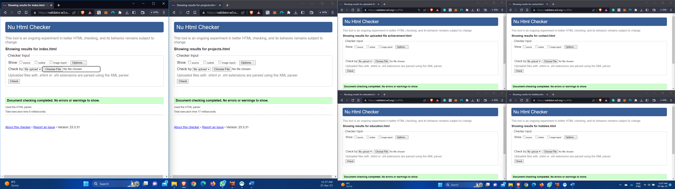

2-

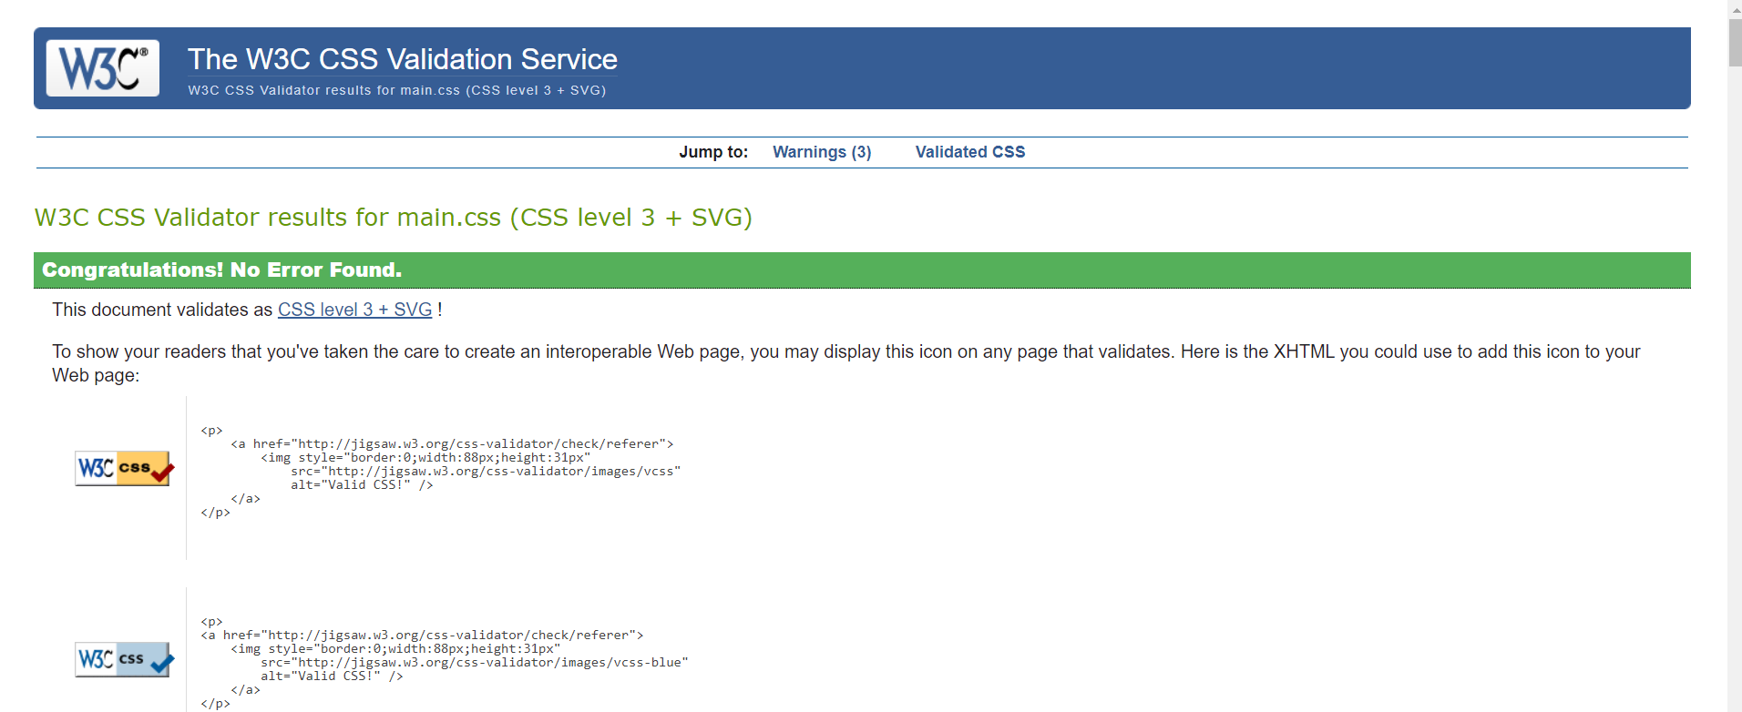

3-

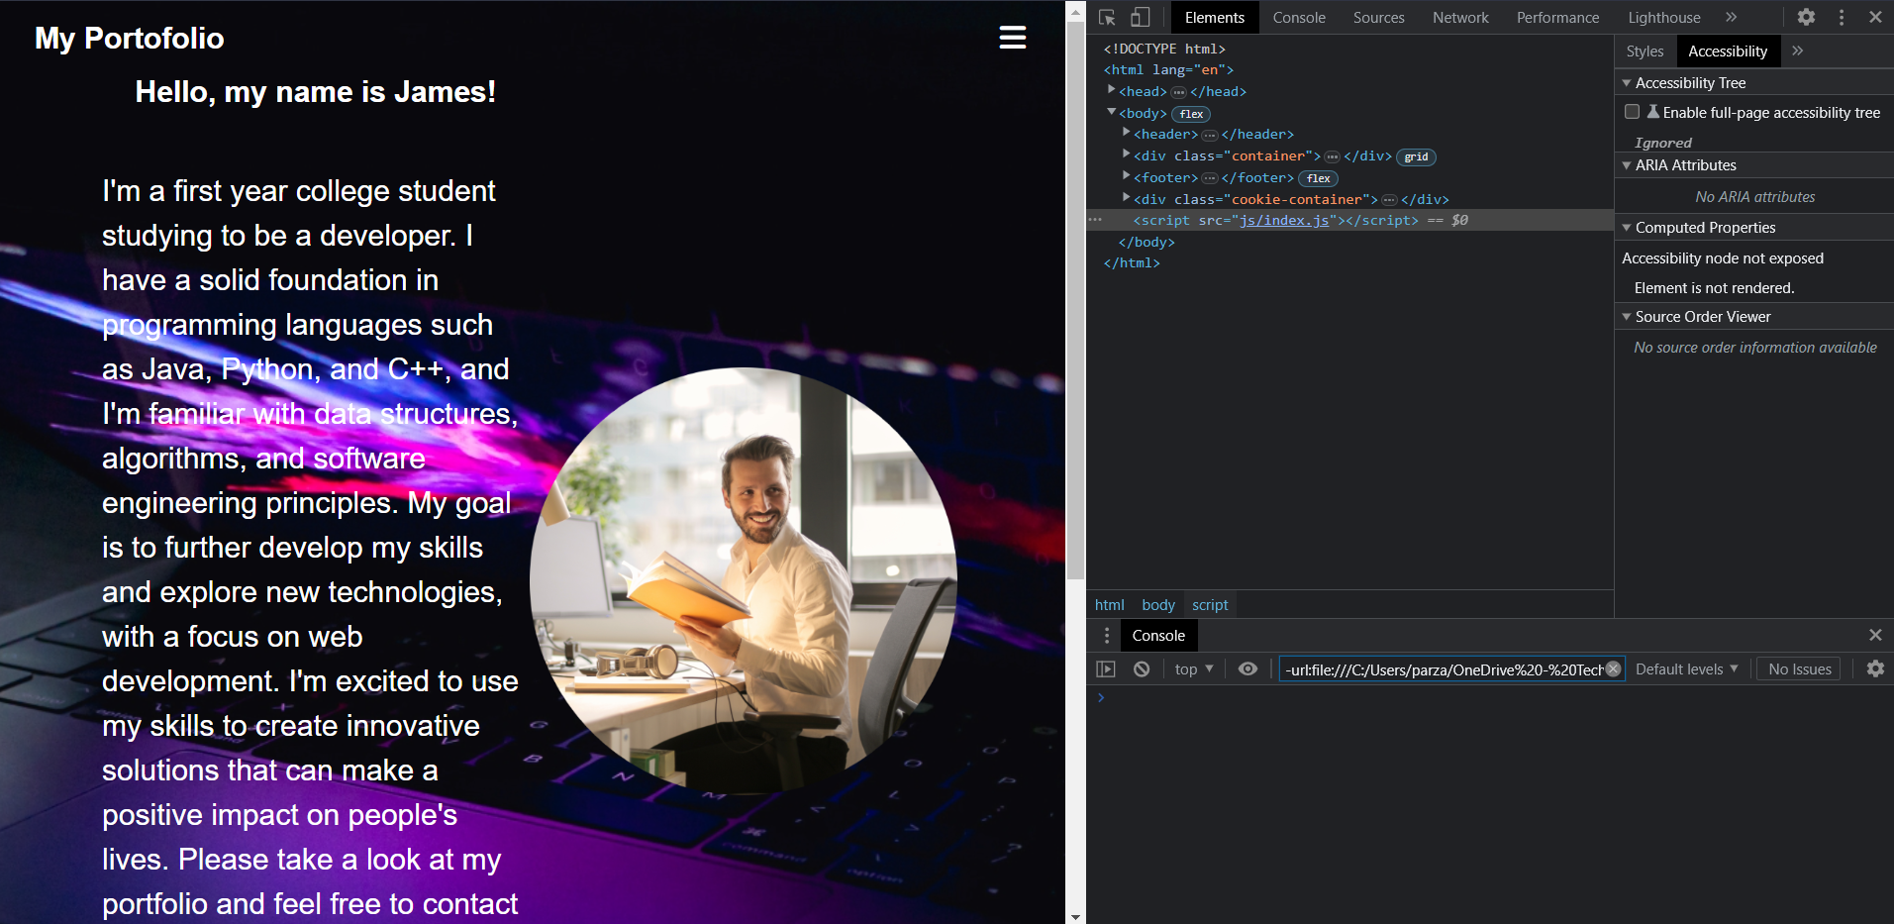

4-

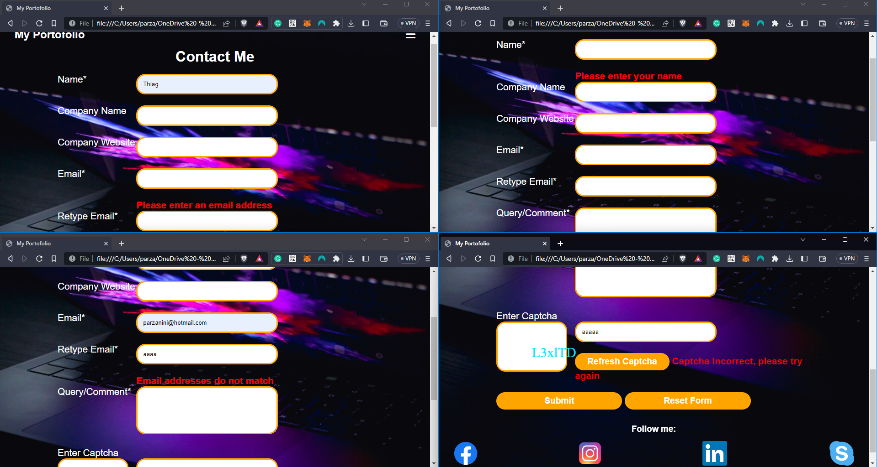

6-

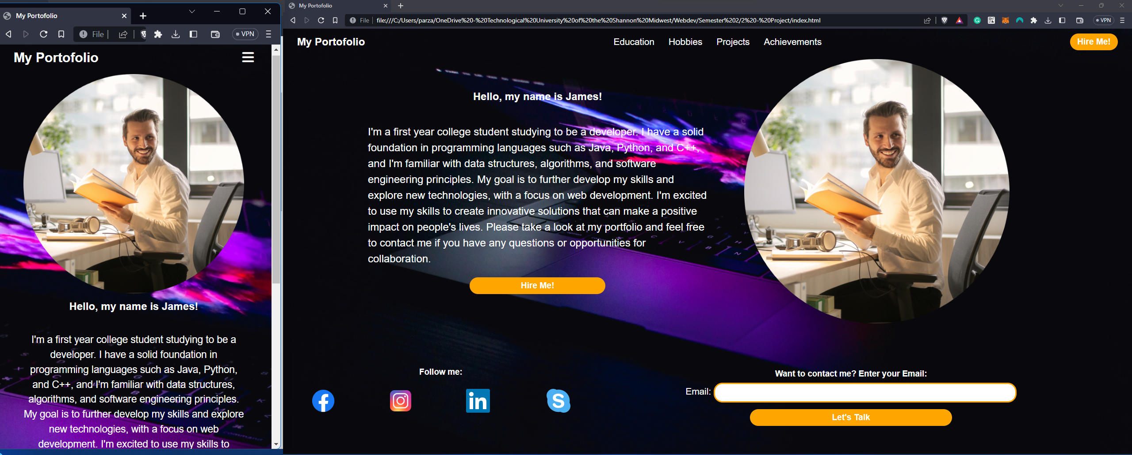

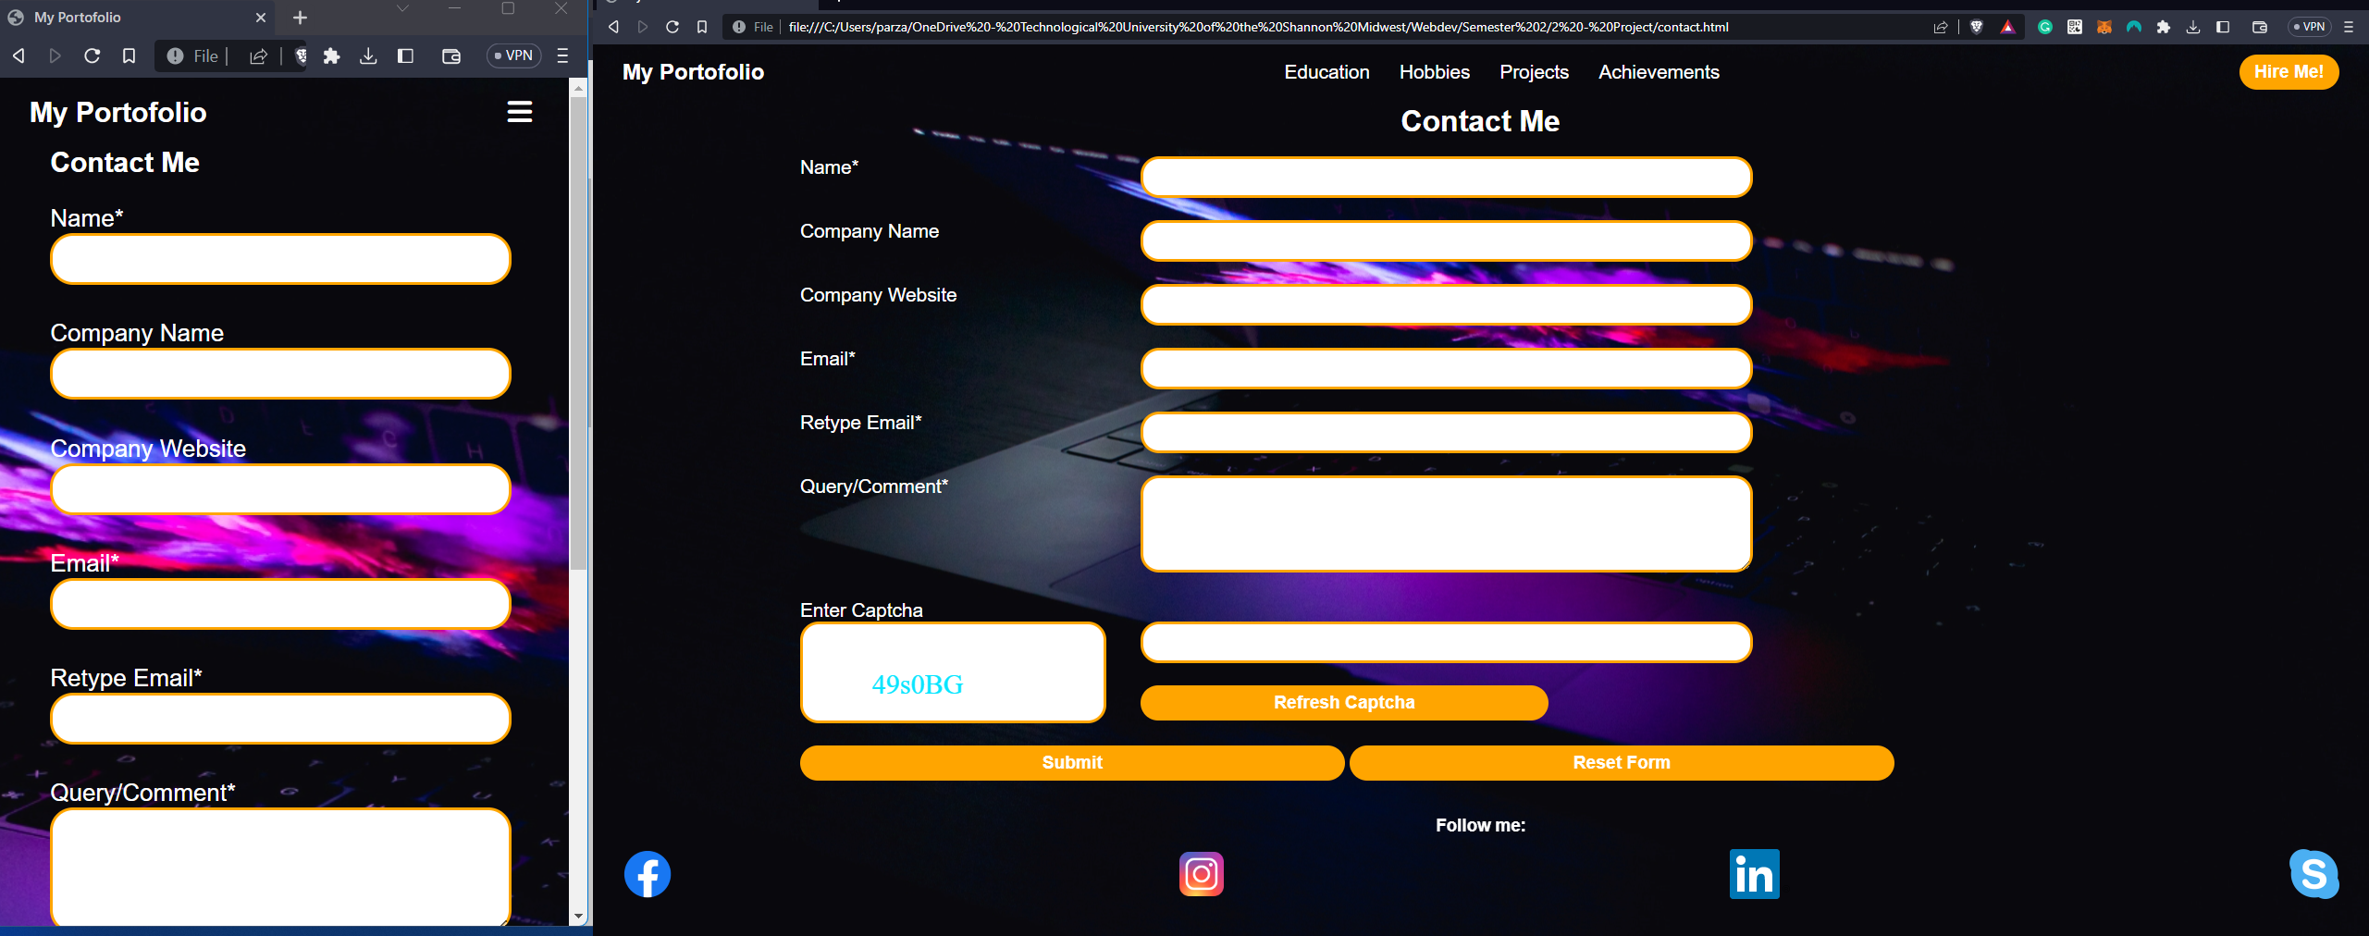

7-

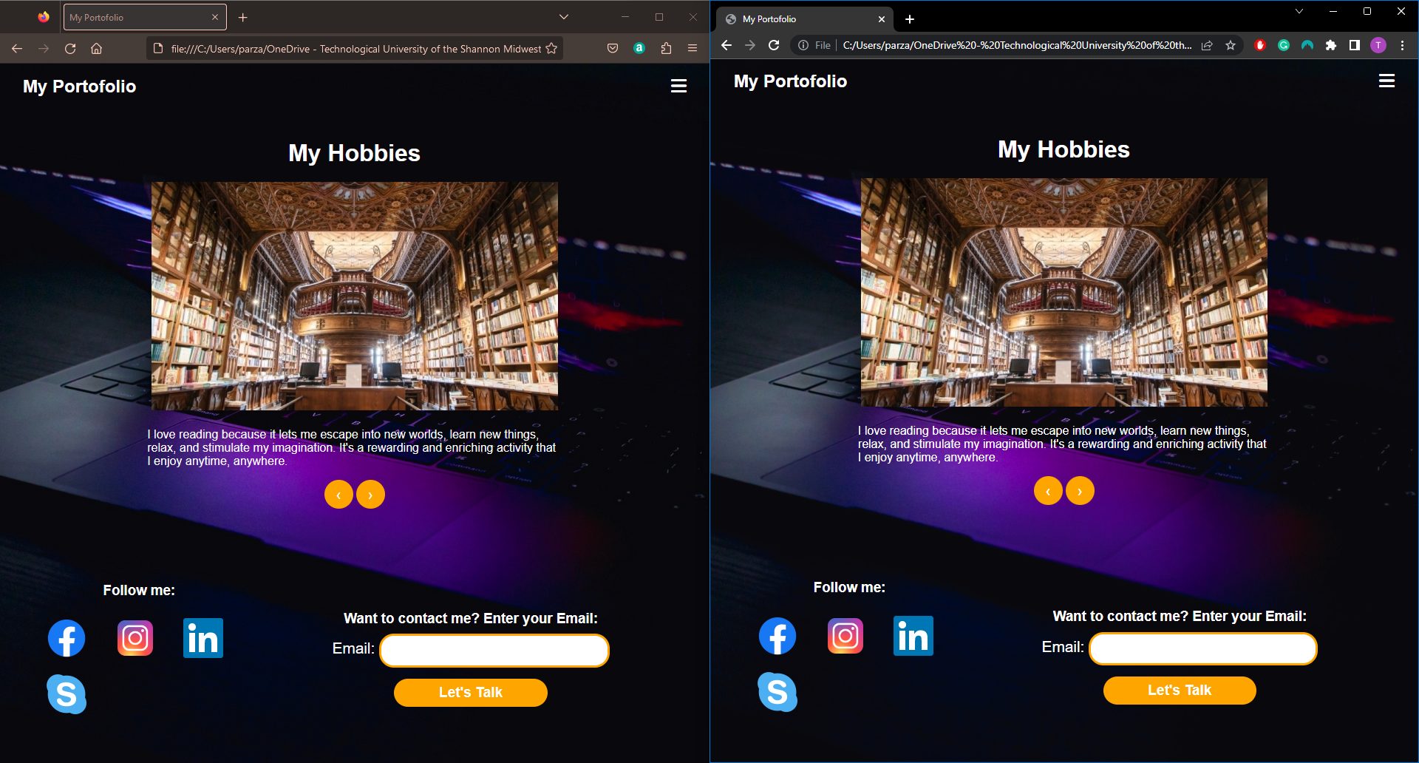

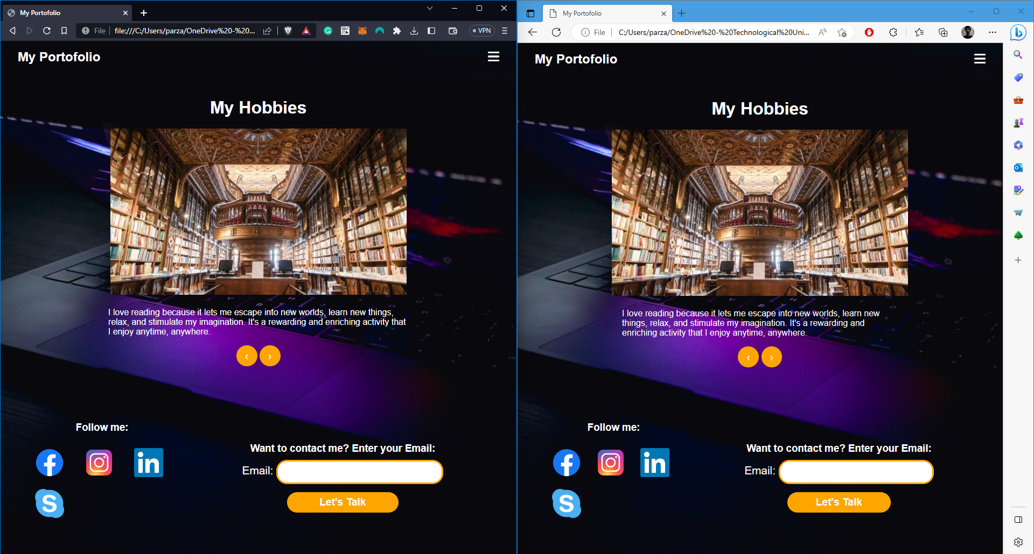

9-

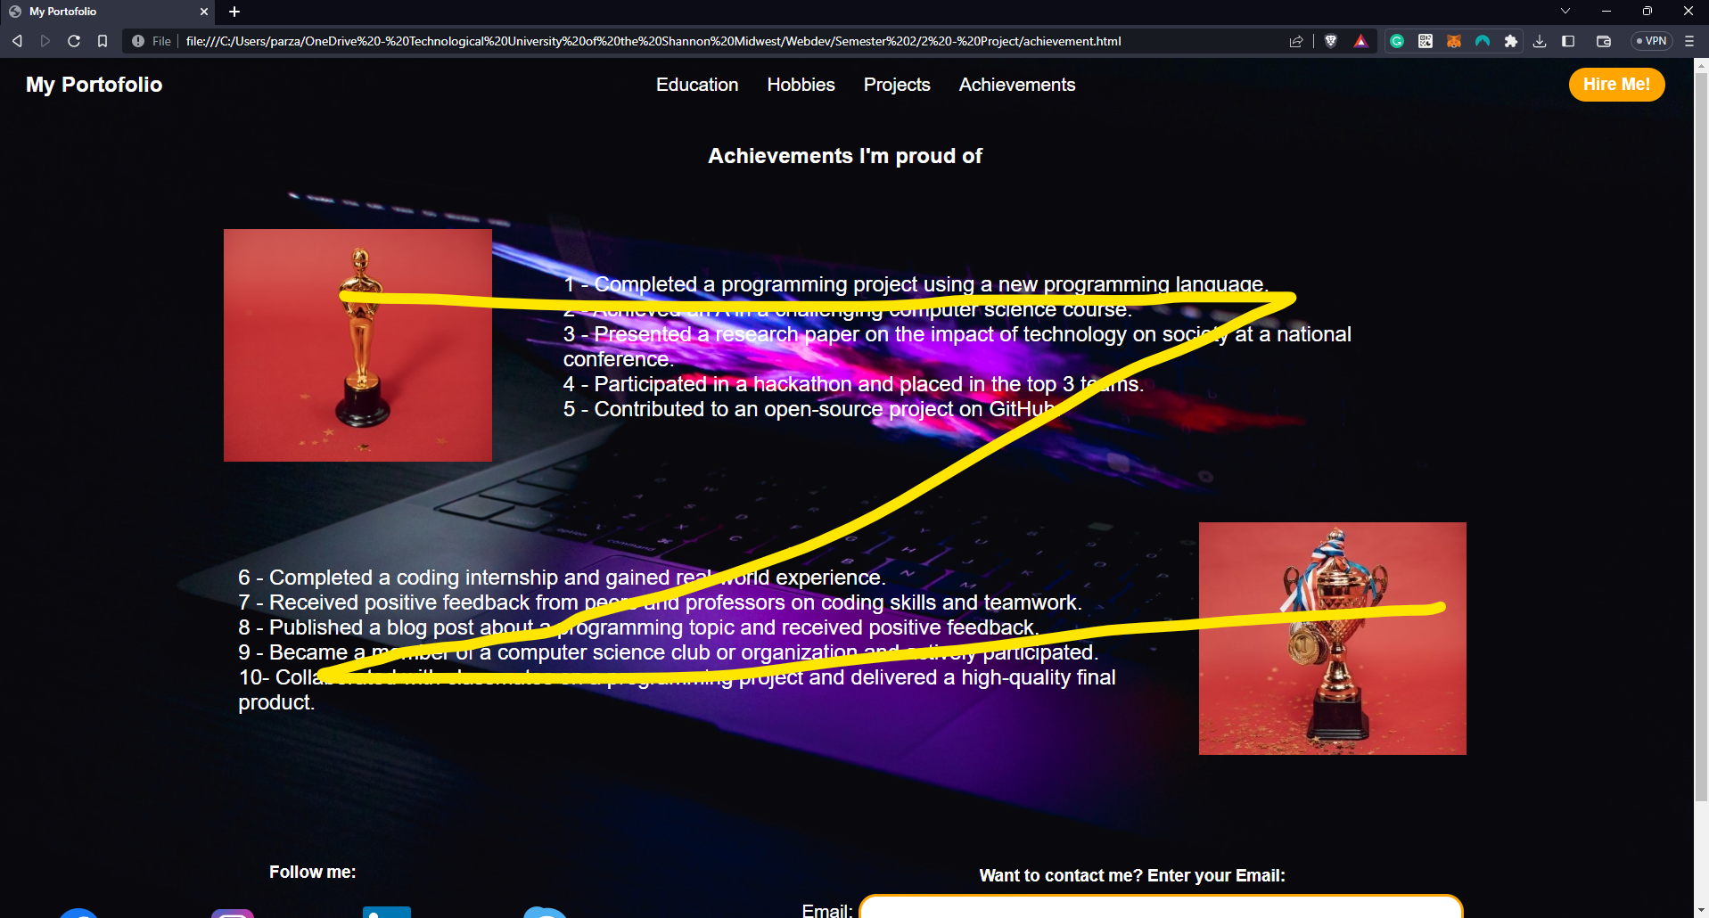

10-

Example of Alignment and Symmetry



Pages use same color, shapes and patterns to create a brand identity, example of Repetition.

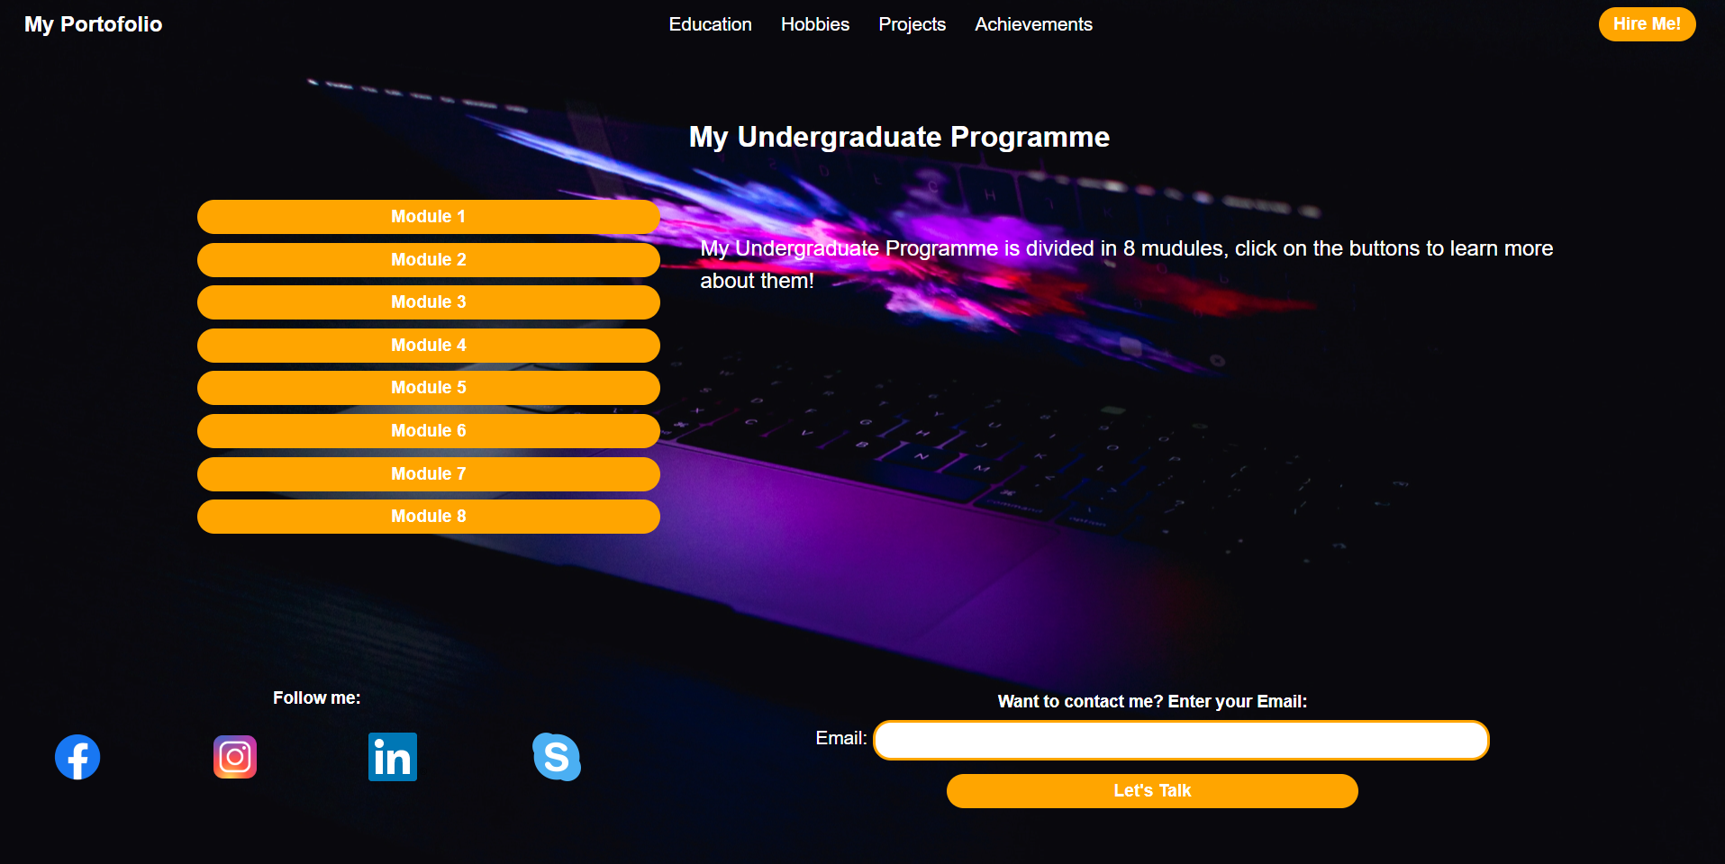

Example of Contrast, differences in color, size, shape, texture, or other visual elements to create visual interest and emphasize important elements

